## **Depth First Search Algorithm**

A standard DFS implementation puts each vertex of the graph into one of two categories:

1. Visited

2. Not Visited

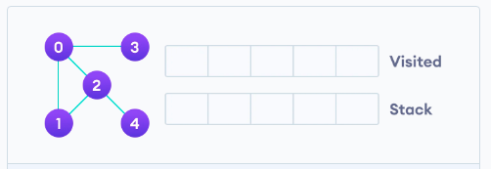

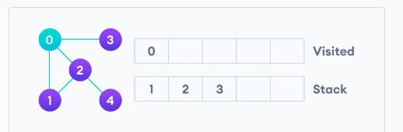

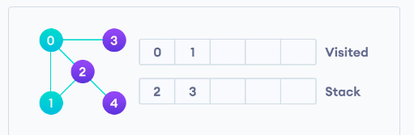

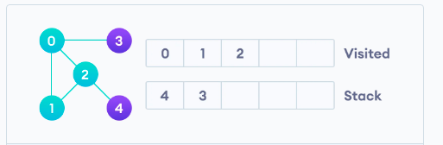

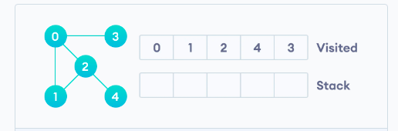

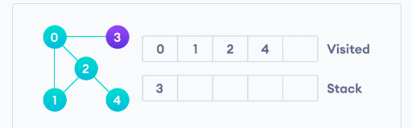

**Application**

1. Minimum spanning tree and all pair shortest path tree

2. Detecting cycle in a graph

3. path finding

4. Topological sorting

5. to test if a graph is bipartite

6. solving puzzle with one solution

7. finding strongly connected components of a graph